Juvenile Fisheries Habitat

Assessment, Sarasota Bay, Florida

VHB served as the prime consultant for a study to inventory critical estuarine nursery habitats of Sarasota Bay and to assess fishery utilization of natural wetlands, restored wetlands and artificial reefs within the bay. The Sarasota Bay study area encompassed more than 52 square miles of open water, tidal lagoons, mangrove forests, salt marshes, salterns, tidal flats, oyster bars and hard bottom located within Sarasota and Manatee Counties on the west-central coast of Florida.

The initial inventory and resource assessment involved habitat mapping by photointerpretation and ground-truthing and creation of a GIS database for (a) shore type features; (b) tidal wetland features and (c) seagrass features with a 16-zone bay segmentation scheme previously adopted by the Sarasota Bay Natural Estuary Program (SBNEP). Query analyses of the database were performed to tabulate and chart the proportion of the features within the entire study area and within each bay segment.

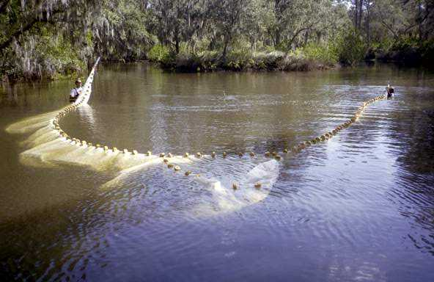Based on an in-field inventory of microhabitat features of natural and restored shore-fringing habitats, 40 stations were established for seasonal (February and June) sampling of juvenile fishes by seine. Eighteen stations were located in restored sites and twenty-two within natural habitats. All fish and selected shellfish and invertebrates were identified in the field to the lowest practical taxon. All commercially or recreationally important fish species within each sample were counted and a sub-set was measured. Water temperature and salinity were recorded for each sampling event and microhabitat characteristics, e.g., bottom type, vegetation presence, etc. were documented. The database was extracted to grid files in MS Excel software environment and statistical and community software programs were used to compute parameters.

The artificial reef assessment involved a diver’s characterization of 10 artificial reefs for reef structure and configuration. The survey further identified material type, e.g., concrete block, rubble, reef balls, limestone boulders, etc. A scale of 1 to 5 was used to rank each reef as to complexity with the highest rank indicative of a variety of holes, material sizes and high vertical relief. Three reefs were subsequently selected for monitoring based on variety of materials, proximity to tidal passes and presence of prefabricated reef balls. Fish populations at each selected reef were monitored seasonally (February and June) using point census and linear transect methods by SCUBA diver at 14 stations. Four surveys were performed at each reef. All data was entered into a MS Access database and was analyzed using MS Excel and SPSS software (raw abundance, density, catch-per-unit-area).
Location
Sarasota Bay, Florida
Client
Sarasota Bay National Estuary Program
Completion
October 2002

