
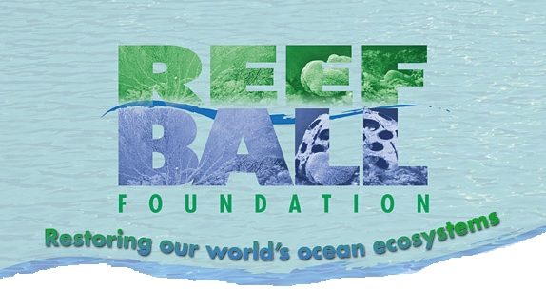

Certificate of Recognition
from the

This Certifies That Debbie OHare Has Achieved Level I
Level VI: Is adequately knowledgeable about coral species and handling techniques to function as a team leader or co/leader
Level V: Is adequately knowledgeable about mangrove plantings to function is a team leader or co/leader
Level IV: Has participated in a Reef Ball Foundation monitoring project
Level III: Has participated in a Reef Ball Foundation red mangrove planting project
Level II: Has participated in a Reef Ball Foundation coral rescue project
Level I: Has participated in all phases of a Reef Ball Foundation coral propagation project

This certificate allows the bearer to be eligible for participation on the Reef Ball Foundation’s Service Team Projects

